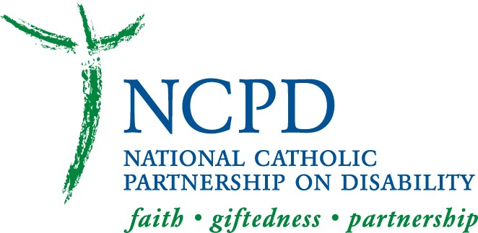 2019-2020 (July – June) NCPD AFFILIATE MEMBERSHIP

Name: ______________________________________ (Arch)Bishop of: _____________________________

Address: ____________________________________________________________________________

City: ____________________________________ State:_________________ Zip______________

Telephone: ________________________________ FAX Number: _____________________________

Enclosed is the 2019-2020 NCPD Affiliate Membership donation: $__________________________
Make check payable to “NCPD” ($750 Requested)
Send to: NCPD, 415 Michigan Ave. N.E., Ste. 95, Washington, DC 20017-4501

The National Catholic Partnership on Disability (NCPD) provides clergy and pastoral staff with technical resources, training and advocacy on issues related to access to faith for Catholics with disabilities, all faithful to Church teaching. NCPD works on behalf of the estimated 14 million Catholics with a disability.
NCPD was founded 30 years ago with a grant from the Catholic Bishops’ Home Missions Office to implement the 1978 Pastoral Statement of US Catholic Bishops on People with Disabilities. NCPD relies on (arch)diocesan affiliate memberships of $750 for part of its support; foundations, individual donors and product sales make up the rest. NCPD works closely with many offices in the USCCB to provide innovative resources and training that further the priority goals of the US Catholic Bishops.

NOTE: The Board of Directors of NCPD requests that we confirm with Your Excellency the name and title of the individual on your staff with primary responsibility for assuring access and inclusion for members of your flock who are disabled:

Name*: _________________________________________________________________________

Title: __________________________________________________________________________

Address: _______________________________________________________________________

City: ___________________________________________ State: _________ Zip: _____________

Telephone: ______________________________________ FAX:___________________________

E-Mail Address: ____________________________ Website Address: _______________________

* IF YOUR DIOCESE HAS OTHER PERSONS ON STAFF WHO ARE ALSO TO BE INCLUDED ON OUR WEBSITE, please add their information on a separate sheet. If we do not receive other names we will delete names from the past that are on our website now. THANK YOU!

Make check payable to “NCPD"
Send to:
NCPD
415 Michigan Ave. N.E., Ste. 95, Washington, DC 20017-4501
202-529-2933 (v); 202-529-2934 (tty); 202-529-4678 (fax)

